**TRIBHUWAN UNIVERSITY**

**FACULTY OF HUMANITIES AND SOCIAL SCIENCES**



**Project Report on 2D Breakout Game**

**Submitted To:**

Department of Computer Application

National College of Computer Studies

**Submitted By:**

Samman Phuyal

BCA Fourth Semester

NCCSBCA076

August 2023

**Under the Supervision of**

**Mr. Chhetra Bahadur Chhetri**

# **ABSTRACT**

2D Breakout is a video game that originated during the late 1970s in arcades. The game was developed by Atari Inc. in 1976. I made an interactive game based upon the classic game brick breaker. The object of brick breaker is to break the bricks that are distributed around the top of the game screen. The bricks are broken after coming in contact with a ball that bounces around the screen. At the bottom is a paddle that in the classic game moves based on user input. The user has to make sure the ball bounces off the paddle without going off the bottom of the screen.

# **ACKNOWLEDGEMENT**

I would want to express my gratitude to my supervisor, **Mr. Chhetra Bahadur Chhetri**, for his invaluable mentoring, which included encouraging words and practical advice. Additionally, I want to thank **Mr. Santosh Maskey**, our Vice Principal, for monitoring, directing, and inspiring us throughout every stage of this project. I appreciate all of the supervisors', friends', and family's support in making this project successful.

Samman Phuyal

# **TABLE OF CONTENTS**

**ABSTRACT** i

**ACKNOWLEDGEMENT** ii

**TABLE OF CONTENTS** iii

**LIST OF ABBREVIATIONS** v

**Introduction** 1

**1.1** **Introduction** 1

**1.2** **Problem Statement** 1

**1.3** **Objective** 1

**1.4** **Scope and Limitation** 1

**1.5** **Report Organization** 2

1.5.1 Introduction 2

1.5.2 Background Study and Literature Review 2

1.5.3 System Analysis and Design 2

1.5.4 Implementation and Testing 2

1.5.5 Conclusion and Future Recommendations 2

**Background Study** 3

**2.1** **Background Study** 3

2.1.1 Study of existing system 3

**System Analysis and Design** 4

**3.1** **System Analysis** 4

3.1.1 Requirement Identification 5

3.1.2 Feasibility Study 5

3.1.3 Flowchart 6

3.1.4 Usecase 7

**Implementation** 8

**4.1** **Implementation** 8

4.1.1 Tools Used 8

4.1.2 Algorithm Details 8

**Conclusion and Future Recommendation** 9

**5.1** **Lesson learnt/ Outcome** 9

**5.2** **Conclusion** 9

**5.3** **Future Recommendations** 9

**Appendices** 10

**Screenshot of Output:** 10

**References** 12

# **Introduction**

## **Introduction**

Every once in a while people, be it kid or an adult, wants to escape from reality. This can be done through lot of ways and games are one that I feel people connect to a lot and have memories connected to it.

A **2D Breakout Game** where a person is reminded of the old time, the nostalgic feeling of playing an arcade. Made with AI similar to the one we had in our arcades, mobile phones which is sure to bring back memories of the good days.

## **Problem Statement**

Now when everyone thinks a good game needs heavy graphic and many other qualities that requires tons of resources to make, but there are other games that proved it wrong by just having simplest form of graphics and game mechanism it can be just as good as the games made with thousands of dollars of budgets.

Games like **Tetris** proved to be successful in the world of competitive games as well as some casual games to pass some time.

**2D Breakout** is also a game that has minimalistic graphic and rules to learn but can be played casually and competitively.

## **Objective**

The main objective of 2D Breakout Game is:

* To implement the algorithm and functions we have learnt and put it into real life use.
* To prove that even a game that does not have more content and have minimum graphics can be good as the games with more massive content and complicated designs.

## **Scope and Limitation**

The domain of this project is to allow users to play game from any place at any time from their own choice of device. The main drawback of this project is that users won’t be able to choose difficulty levels according to their preference.

## **Report Organization**

### Introduction

Chapter one introduces the concept of this project. It describes the problems that has been existing and how its objective can tackle it. It also presents the scope and limitations of the project.

### Background Study and Literature Review

This chapter focuses on the basic ideology of how this project will be build. It traces out the study of different platforms and their workings.

### System Analysis and Design

This chapter describes the requirements gathering, feasibility study, and designing of the project. It includes diagrams, functionality analysis, requirement gathering technique and process model.

### Implementation and Testing

This chapter is designed to give information about how the project has been implemented, what kind of software and tools has been used and the type of testing that the project has gone through.

### Conclusion and Future Recommendations

This chapter includes the possible outcome of this project, conclusion and future recommendations.

# **Background Study**

## **2.1 Background Study**

It is the study of history of 2D Breakout Game, how it emerged and when did it started gaining popularity. The existing systems has been studies as the background study for this project.

### Study of existing system

Many Brick Breaker Game websites and application were visited for the purpose of system study. These websites includes The classic Brick Breaker for Nintendo, Older Arcade sites, etc. These websites provide immense features which can be both easy to use and learn. These websites allow user to play games with minimum latency.

# **System Analysis and Design**

## **System Analysis**

In this project, the Prototyping Model for the SDLC was adopted. Because of the requirements of this project, which may occasionally alter or demand regular modifications. Therefore, employing a prototype strategy was the ideal method for ensuring that this project's development proceeded smoothly.

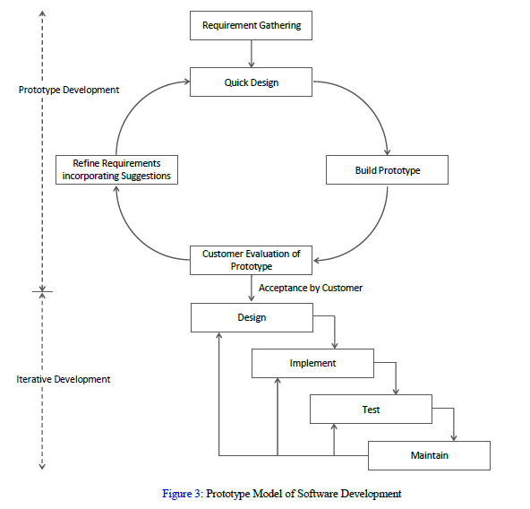

### Requirement Identification

2D Breakout is played solo i.e. player plays this game alone to hit bricks. This project was started because of the previous system study that I found in internet.

Functional Requirements of 2D Breakout Game:

1. Left and Right Arrow keys: Left Arrow-left, and Right Arrow-Right to change the paddle’s direction.
2. The ball has velocity in the direction it’s moving.

### Feasibility Study

1. Technical Feasibility: Using various approaches to test the technical implementation of project using available hardware, software and technology, it is noticed that the project can be implemented using existing technology.
2. Operational Feasibility: The system is tested under several circumstances with varying inputs in unit approach of testing to integrated approach of testing.
3. Economic Feasibility: Since, our system uses simple hardware components which are easily available. Thus, the overall system is economically feasible to be implemented by users.

### Flowchart

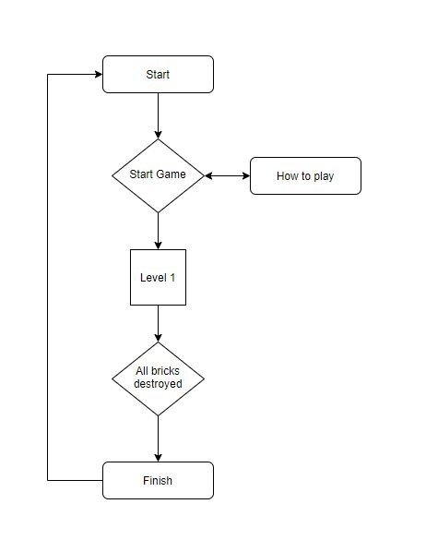

### Usecase

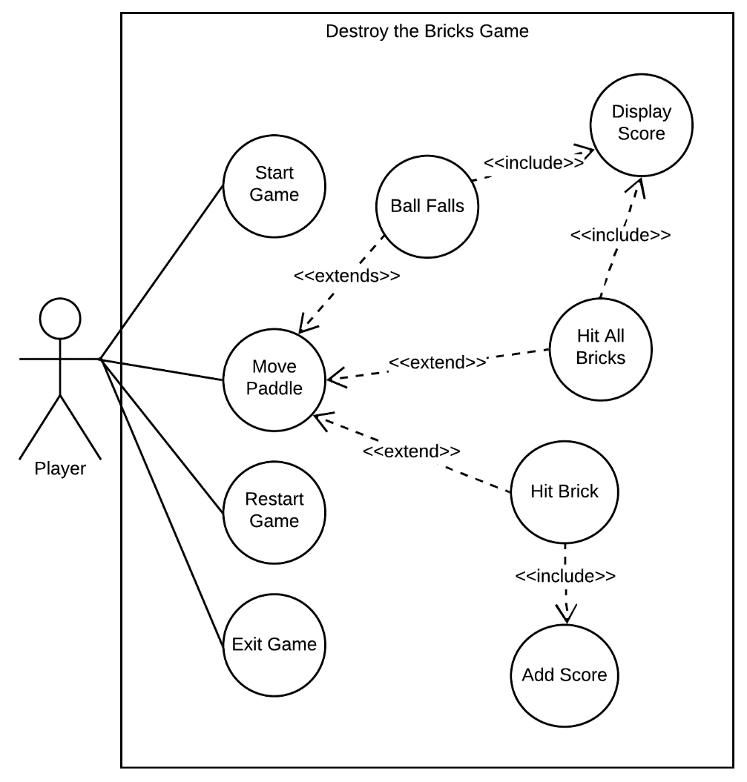

# **Implementation**

## **Implementation**

### 4.1.1 Tools Used

* VS Code
* Eclipse IDE

### Algorithm Details

This programming project is designed with the use of linked lists structure. Testing can be integral tool for checking knowledge and driving learner engagement. The algorithm used in 2D Breakout Game will be Evolutionary Algorithms (EA).

Step 1: Create a paddle X on the middle of the screen at the bottom

Step 2: Create a ball.

Step 3: Create an event to move the paddle vertically.

Step 4: Create an event where the ball moves toward the side of the screen.

Step 5: Create an event where the ball bounces when it is blocked by the paddle.

Step 6: Create a scoreboard.

# **Conclusion and Future Recommendation**

## **Lesson learnt/ Outcome**

The project will allow users to play 2D Breakout Game any time they want. It helps to learn patience and is productive.

## **Conclusion**

This project is expected to deliver a high performance with attractive and easy to use UI. This project will meet all of its objectives as well as address all the shortcomings that has been observed.

## **Future Recommendations**

2D Breakout can further be enhanced by providing Basic functionalities as well as customized music. It can also have High Score facility.

# **Appendices**

## **Screenshot of Output:**

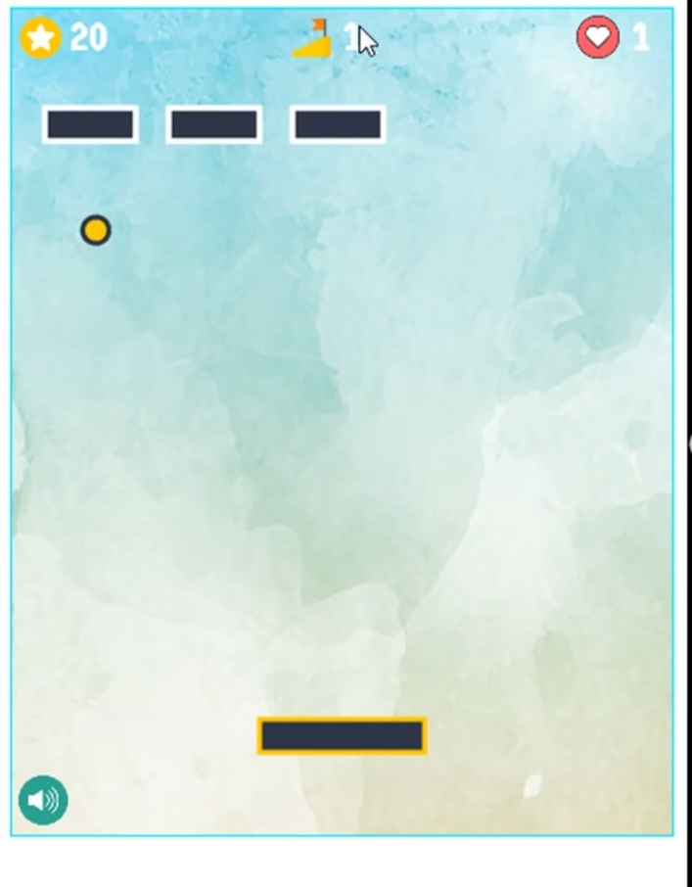

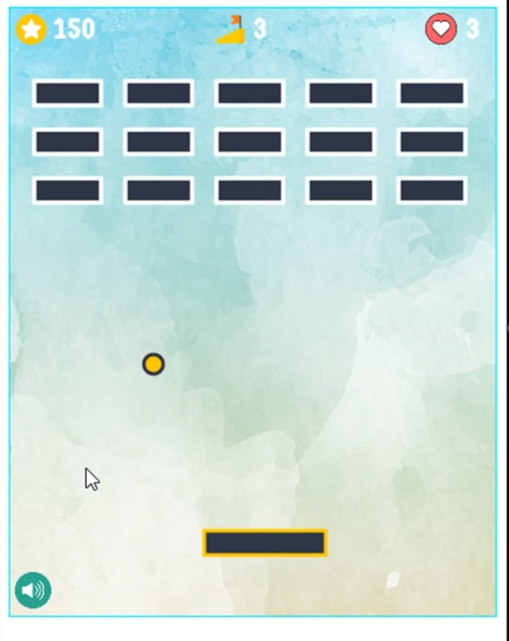

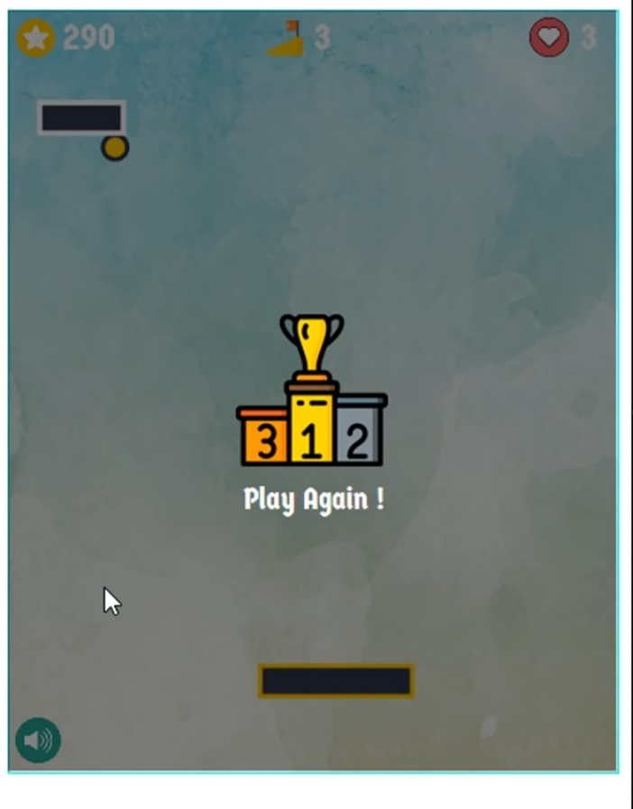

# **References**

"Ali Asaria's linkedin profile". February 21, 2021. Archived from the original on 2008-01-22.

Shelley Fralic (November 19, 2010). "Ex-video game foe is now addicted to zapping bricks". The Vancouver Sun. Retrieved September 27, 2019 – via PressReader.

Jessica E. Vascellaro (August 9, 2007). "Beyond Brick breaker". The Wall Street Journal. Retrieved September 27, 2019.